**Lab 2 Submittal Document**

**Project 1:**

**Step 1: Downloading and Setting up SQL Developer**

SQL Developer Landing Page

**Step 2: Connecting to Live Oracle server.**

Connection Successful

The connection details are as follows:

Connection name: Harshal  
Username: ora_hsawant1  
Connection Type: Basic  
Role: default  
password: oracle  
hostname: [www.papademas.net](http://www.papademas.net/)  
port: 1521

**Project 2: Using Oracle to create a DB File**

**Step 1: Use SQL to create a Database Table**

We opened the audio.sql file through the Oracle SQL Developer and ran the mentioned script, which resulted in the table being created.

**Step 2: Use SQL to describe the table.**

* Which field is described as "Not Null"?
* **NUM_ID**

**Step 3: Populate the table from your datasheet information in the table.**

The “COMMIT” command will save the inserted value in the database.

**Step 4: Supplement Audio Table with Five additional records.**

Here we have added 5 new records which can be seen from NUM_ID 23 to 27.

* The last record of NUM_ID 27 is the one with my name as the ARTIST.

**Step 5: View the records in the table**

Select * FROM audio – shows all the entries in the table

**Project 3: Creating Queries using SQL**

**Step 1: create database query using SQL**

**Step 2: Modify the SQL code**

**Step 3: Create Four New Queries in SQL**

**New Query 1:**

I have displayed the PRICE field to be more specific about the price range.

**New Query 2:**

**New Query 3:**

**New Query 4:**

**Project 4: More Table Queries**

**Step 1: Create Database Query**

**Step 2: Run the Next Database Query**

**Step 3: Change to the SQL View**

Displaying ARTISTS starting with letter M

Displaying ARTIST with starting letter E or Title between A and M or Price less than 12

**Project 5: “AND” vs “OR”**

**Query One:**

Theres no output for the following query.

**Query Two:**

**Query Three:**

**Query Four:**

**Project 6: SQL Developer Questions**

1. What are at least 4 errors that may occur when creating and populating a database table?

* This answer depends on individual mistakes/complications but some of them can be:
* Syntax Errors
* Constraint Errors
* Range Error
* Data Type Mismatch errors
* Network Errors or issues while populating
* Typing wrong logical operators

1. What is a null value for a field and when does it occur?

* A NULL value in a table in a SQL database means there's no clear or definite data in that spot. It's like saying, "I don't know" or "there's nothing here" in the database. It's not the same as leaving a space empty or putting a zero there.

In SQL, NULL values can show up in different situations. For instance, when a column doesn't have a rule that says it must have data (NOT NULL), when a table is made with a default NULL value, when someone deliberately puts NULL in a column, or when a calculation or function doesn't have a clear result. Whenever something should be in the database, but it's not, NULL is used to show that. It's not like having an empty space or putting a zero there.

1. What effect does a null value have when calculating the average value for a numeric field ( like salary ) ?

* In SQL, when you want to find the average of numbers, like salaries, the database usually doesn't count the empty or missing values (NULL). It only looks at the numbers that are there, not the ones that are missing, to calculate the average. This way, the average is only calculated from the numbers you have, not the ones you don't have.

1. What will / should a user be able to do if the table becomes corrupted?

* If a table gets messed up, people should first notice the problem and understand what it means. To make sure the data is safe, they should bring back the table from a backup if they have one. Before trying to fix it, they can use the tools in SQL Developer to get data from the messed-up table. The way to fix it might be different depending on which database system they're using, like Oracle, MySQL, or Microsoft SQL Server. People should talk to the database boss and check the database's instructions for more help

1. SQL Developer Menu Icons

* .a) SYSDATE:

The built-in function SYSDATE in SQL Developer receives the current date and time from the database server's system clock. The timestamping of records during insertion or update operations, date-based query filtering, and establishing default values for timestamp columns are all common uses of this method. The current system timestamp may be easily included in SQL queries, enabling users to deal with real-time data and efficiently handle temporal elements of their databases.

* b&c) Output of each and every button and their meaning:

**Run Statement:**

Users can conduct queries, changes, or any other SQL command against the connected database by using the Run Statement, which executes the SQL statement or code block that is presently chosen.

**Run Script:**

An whole SQL script file comprising several SQL statements may be run using the Run Script command. It enables users to execute a series of instructions, produce database objects, or instantly fill tables with data from a single file.

**Explain Plan:**

Explain A SQL statement's execution plan is generated and shown by Plan. It assists in query performance optimisation by giving users insights into how the database engine will handle the query, revealing details about indexes, joins, and other processes.

**Autotrace:**

The number of rows handled and the execution time may both be quickly generated and shown for a SQL query using Autotrace. By giving useful information about the query's resource utilization and efficiency, it assists users in analyzing and optimizing query performance. The error notice "Insufficient privileges" indicates that the user account 'ORA_HSAWANT1' attempting to access the Autotrace tool in SQL Developer does not have the required permissions to perform the requested action. The error message in this case shows that there was a problem accessing an object or schema with the name "V4MYSTAT." To resolve this issue, a database administrator must provide the user "ORA_HSAWANT1" the required permissions. You may ensure that the user has access to the features and the SQL Developer Autotrace tool by providing the necessary permissions.

**SQL Tuning Advisor:**

SQL Tuning Advisor tool analyzes SQL statements and provides recommendations for improving their performance. It offers suggestions such as creating indexes, restructuring queries, or using different optimization techniques, helping users optimize their SQL code for better database performance. The error message "Action required: To run SQL Tuning advisor, user 'ORA_HSAWANT1' requires System Privilege ADVISOR" indicates that the user is unable to perform SQL tuning operations because they lack the necessary system privilege, 'ADVISOR'.

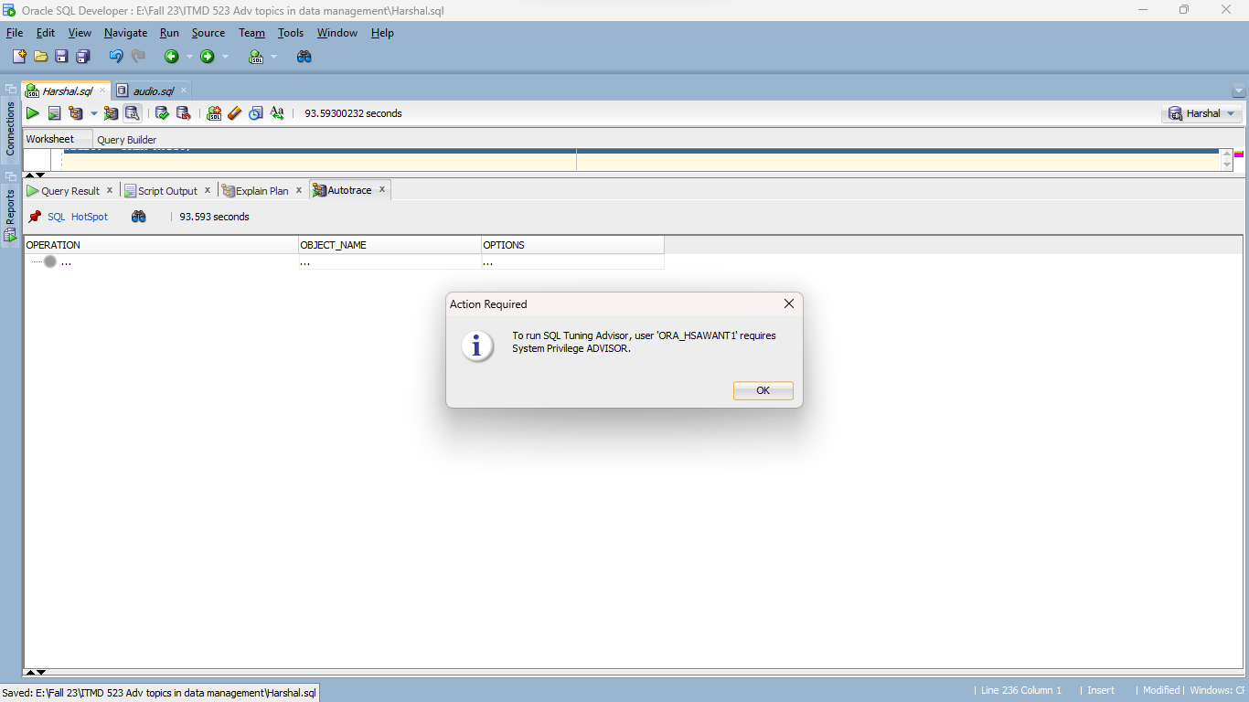

**Commit:**

Any modifications performed during the ongoing database transaction are saved permanently by using the commit command. When clicked, the transaction is terminated, making all modifications permanent and available to other users.

**Rollback:**

Any modifications made during the current database transaction can be undone with rollback. When selected, it undoes any changes performed during the transaction, restoring the database to its initial state and, in essence, canceling the transaction.

There was no specific output for rollback, except the time taken for completing rollback.

**Clear:**

The SQL Worksheet's contents may be cleared with the Clear command, enabling users to start again or undo past queries and operations. It offers a speedy method to clear the workspace and type fresh SQL instructions or statements over empty text fields.

**Unshared SQL Worksheet:**

Unshared SQL Worksheet enables users to launch a fresh SQL Worksheet that runs independently of other worksheets, allowing several queries or activities to be executed concurrently without interfering with one another. For coordinating many database activities within a single SQL Developer session, this capability is quite helpful.

SQL History:

Users may examine, modify, and repeat earlier queries using the list of previously performed SQL statements that SQL History gives. It makes it easier for users to re-execute frequently used or updated SQL statements and keeps track of their query history.

**To UPPER/LOWER/INITCAP:**

The UPPER, LOWER, and INITCAP functions change how the letters in a text column look.

UPPER makes all letters BIG/uppercase.

LOWER makes all letters small/lowercase.

INITCAP makes the first letter in each word uppercase and the rest lower.